Configuring the Sentinel System Driver for Toshiba Satellite Pro running XP Professional after installing Sentinel System Driver 5.41

- Download the latest BIOS patch from the Toshiba web site
- Download the latest Sentinel System Driver, SSD5.41.
- Install the SSD5.41 Sentinel System Driver as normally.
- In Toshiba Hardware, set the printer port to ECP.
- Go to Control Panel/Administration Tools/Device Manager and expand the serial/parallel port. Double click the printer port. Set the port to address 378, IRQ 7 and DMA to 3. One of the standard settings in the drop-down list has this configuration
- Reboot the system

After Reboot:

- Start the driver configuration utility, SetupSysDriver.exe. It is usually located at C:\Program Files\Rainbow Technologies\Sentinel System Driver
- Click the "Configure Driver" button as can be seen in the picture below.

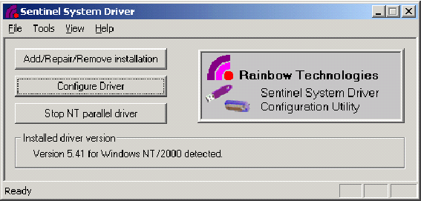

- The following dialog will be displayed. Click the "Add" button.
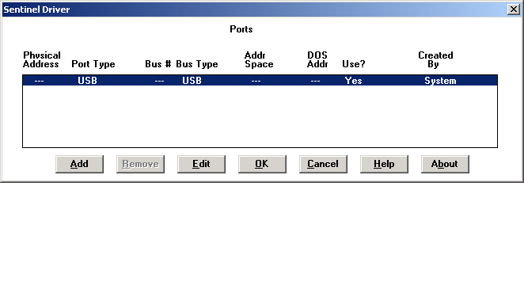
- The following dialog will be displayed. Enter 378 into the I/O address of the PCI parallel port adapter into the "Bus Address" field.

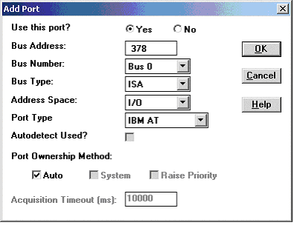

- Click the "OK" button and the following dialog will appear:

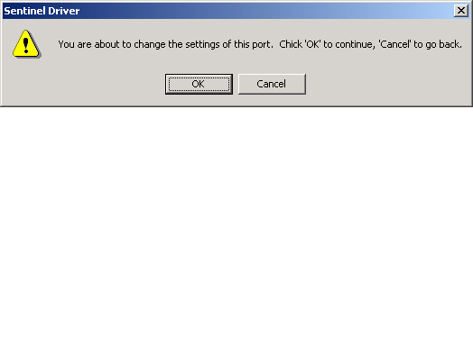

- Click the OK button and the following dialog appears. It shows that a User Created port has been added at address 378.

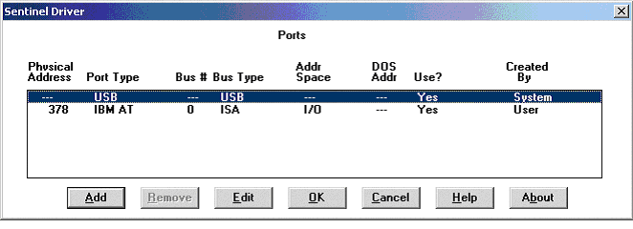

- Click the OK button to close the dialog and then open the File menu and choose Exit to close the Sentinel System Driver Configuration Utility.

